IEEE P802.15
Wireless Personal Area Networks

Project | IEEE P802.15 Working Group for Wireless Personal Area Networks (WPANs)
Title | Channel models for TG8
Date Submitted | September 2012
Source | Marco Hernandez, Huan-Bang Li, Igor Dotlić, Ryu Miura (NICT)
Re: | In response to Technical Guidance Document contributions
Abstract | Channel models
Purpose | Reference channel models for proposals evaluation to TG8
Notice | This document has been prepared to assist the IEEE P802.15. It is offered as a basis for discussion and is not binding on the contributing individual(s) or organization(s). The material in this document is subject to change in form and content after further study. The contributor(s) reserve(s) the right to add, amend or withdraw material contained herein.
Release | The contributor acknowledges and accepts that this contribution becomes the property of IEEE and may be made publicly available by P802.15.

Contents
1 Introduction 3
2 Large-Scale Path Loss 4
2.1 Outdoor Path Loss 4
2.1.1 Propagation situations 4
2.1.2 Line-of-sight (LoS) paths 4
2.1.3 Propagation over rooftops, non-line-of-sight (NLoS1) 5
2.1.4 Propagation along street canyons, non-line-of-sight (NLoS2) 6
2.2 Path Loss for sub-1 GHz, 2.4 GHz and 5 GHz bands 6
2.2.1 LoS in street canyons 6
2.2.2 NoLoS over roof-tops for urban area 7
2.2.3 NoLoS over roof-tops for suburban area 10
2.2.4 NoLoS in street canyons for sub-1 GHz band 12
2.2.5 NoLoS in street canyons for 2.4 GHz and 5 GHz bands 12
2.3 Outdoor Path Loss for UWB band 13
3 Indoor Path Loss 14
3.1 Attenuation Factor Model for 900 MHz band 14
3.2 Indoor Path Loss for 2.4 GHz and 5 GHz bands 17
4 Small-Scale Fading 19
5 Bibliography 20

Introduction

There are numerous contributions to path loss propagation in the literature for the target frequency bands of TG8 indicated in the PAR. Namely, sub-1 GHz, 2.4 GHz, 5 GHz and high band of UWB.
We present the most accepted contributions to be used for a fair comparison of PHY and MAC proposals.

Large-Scale Path Loss

Outdoor Path Loss

Outdoor path loss is based on ITU-R P.1411-6 “Propagation data and prediction methods for the planning of short-range outdoor radio communication systems and radio local area networks in the frequency range 300 MHz to 100 GHz”.
It provides an up to date recommendation for propagation over paths of length less than 1 Km, which is affected primarily by buildings and trees. The effect of buildings is predominant, since most short-path radio links are found in urban and suburban areas. The mobile terminal is most likely to be held by a pedestrian or located in a vehicle.
The type of propagation mechanism that dominates depends also on the height of the base station antenna relative to the surrounding buildings. Table 1 lists the typical cell types relevant for outdoor short-path propagation.

Cell type | Cell radius | Typical position of base  station antenna
Micro-cell | 0.05 to 1 km | Outdoor; mounted above average roof-top level, heights of some surrounding buildings may be above base station antenna height
Dense urban micro-cell | 0.05 to 0.5 km | Outdoor; mounted below average roof-top level
Pico-cell | Up to 50 m | Indoor or outdoor (mounted below roof-top level)
Table 1 Definition of cell types.

Propagation situations
Four situations of base station (BS) and mobile station (MS) geometries are depicted in Figure 1. Base station BS₁ is mounted above roof-top level. The corresponding cell is a micro-cell. Propagation from this BS is mainly over the roof-tops. Base station BS₂ is mounted below roof-top level and defines a dense urban micro- or pico-cellular environment. In these cell types, propagation is mainly within street canyons. For mobile-to-mobile links, both ends of the link can be assumed to be below roof-top level, and the models relating to BS₂ may be used.

Line-of-sight (LoS) paths
The paths BS₁-MS₂ and BS₂-MS₄ illustrated in Figure 1 are examples of LoS situations. The same models can be applied for both types of LoS path.

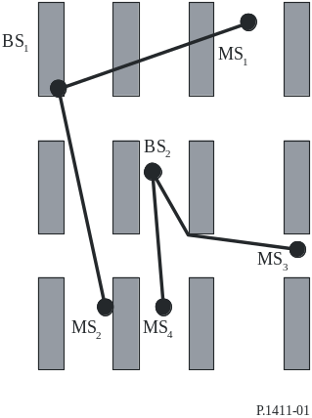
Figure 1 Typical propagation situation in urban areas.

Propagation over rooftops, non-line-of-sight (NLoS1)
The typical NLoS case (link BS₁-MS₁ in Figure 1) is described in Figure 2.

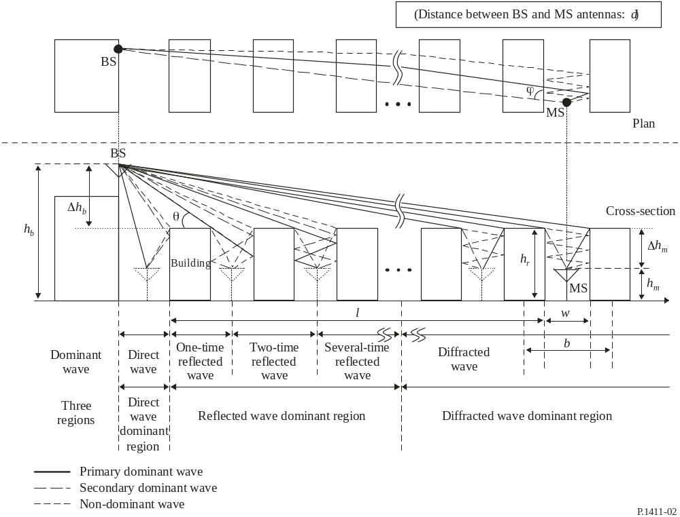
Figure 2 Parameters for the NoLoS1 case.
The relevant parameters are given by
hr : average height of buildings (m)
w : street width (m)
b : average building separation (m)
 : street orientation with respect to the direct path (degrees)
h_{b} : BS antenna height (m)
h_{m} : MS antenna height (m)
l : length of the path covered by buildings (m)
d : distance from BS to MS.

Propagation along street canyons, non-line-of-sight (NLoS2)
Figure 3 shows the situation for a typical dense urban micro-cellular NLoS case, link BS₂-MS₃ in Figure 1.
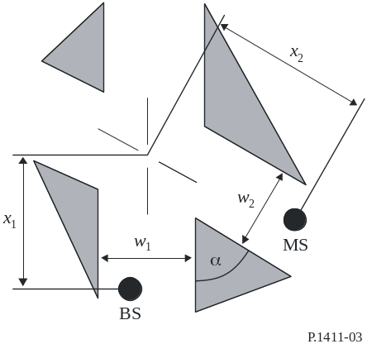
Figure 3 Parameters for the NoLoS2 case.
The relevant parameters are given by
w₁ : street width at the position of the BS (m)
w₂ : street width at the position of the MS (m)
x₁ : distance BS to street crossing (m)
x₂ : distance MS to street crossing (m)
 : is the corner angle (rad).

Path Loss for sub-1 GHz, 2.4 GHz and 5 GHz bands

LoS in street canyons
The path loss is characterized by two slopes and a breakpoint. An upper and lower bounds are provided. However, we propose to use the median value that is given by

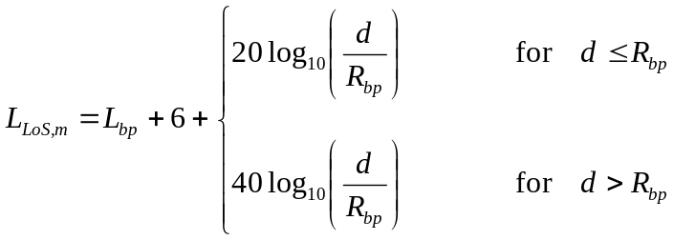 Equation 1
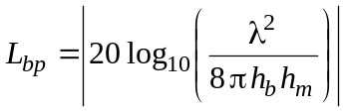 , 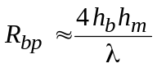, 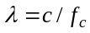.
where L_{bp} is transmission loss at break point, R_{bp} is the breakpoint distance and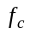is the central frequency.

NoLoS over roof-tops for urban area
The recommendation presents values for which the models are valid. However, for the purposes of comparison of proposals, such values can be relaxed a bit. Models are defined for the two situations described in 2.1.1. The models are valid for:
h_{b}: 4 to 50 m
h_{m}: 1 to 3 m
f: 800 to 5 000 MHz
2 to 16 GHz for h_{b} < h_{r} and w₂ < 10 m (or sidewalk)
d: 20 to 1000 m.
In the model for transmission loss in NLoS for roof-tops of similar height, the loss between isotropic antennas is expressed as the sum of free-space loss, L_{bf}, the diffraction loss from roof-top to street L_{rts} and the reduction due to multiple screen diffraction past rows of buildings, L_{msd}. In this model L_{bf} and L_{rts} are independent of the BS antenna height, while L_{msd} is dependent on whether the base station antenna is at, below or above building heights.

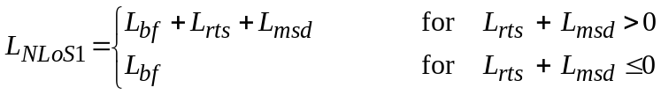 Equation 2
where d is path length, f is frequency (MHz), L_{rts} describes the coupling of the wave propagating along the multiple-screen path into the street where the mobile station is located and given by

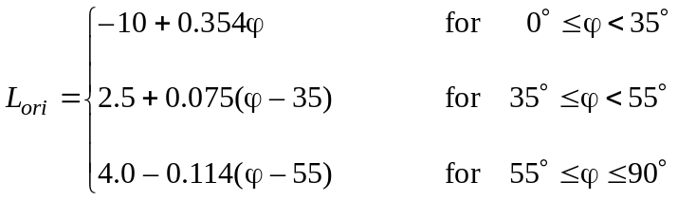
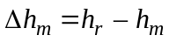
L_{ori} is the street orientation correction factor, which takes into account the effect of roof-top-to-street diffraction into streets that are not perpendicular to the direction of propagation (see Figure 2).
The multiple screen diffraction loss from the BS due to propagation past rows of buildings depends on the BS antenna height relative to the building heights and on the incidence angle. A criterion for grazing incidence is the “settled field distance”, d_{s}:

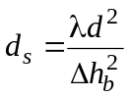 , 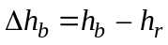
Finally, for the calculation of L_{msd}, d_{s} is compared to the distance l over which the buildings extend:
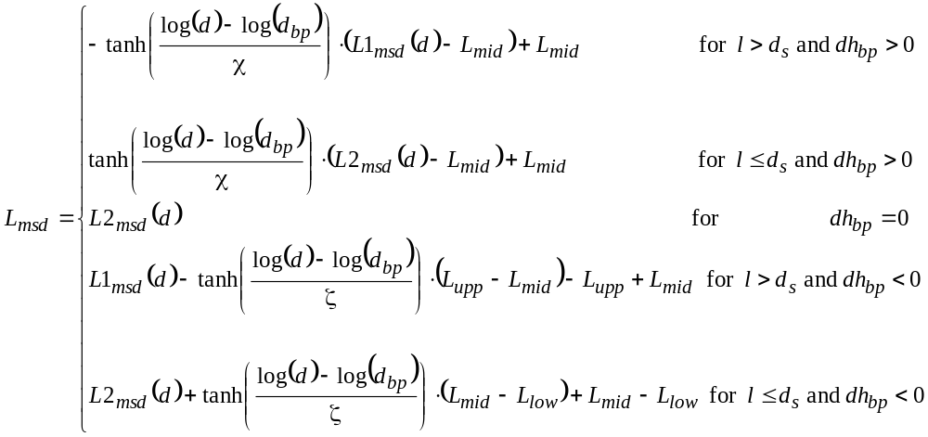
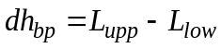

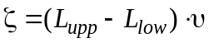

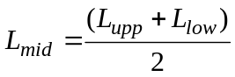

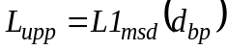

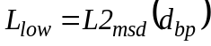
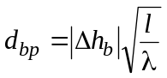
υ = 0.0417
χ = 0.1

Calculation of L1_{msd} for l > d

where:
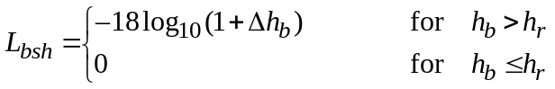

is a loss term that depends on the BS height:

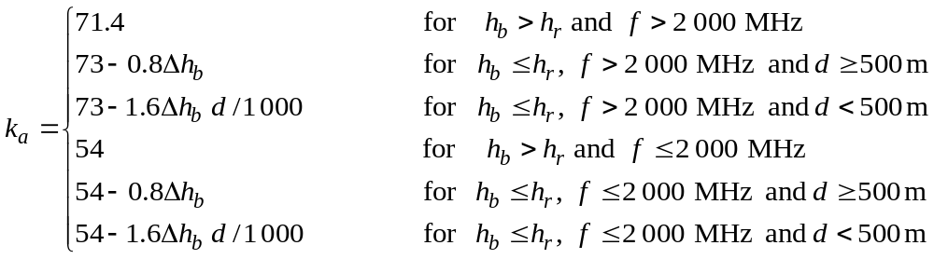

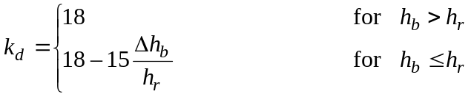
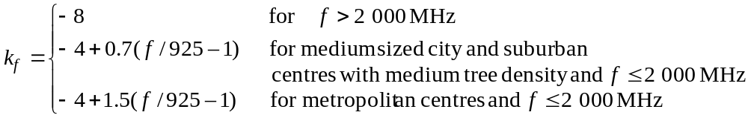

Calculation of L2_{msd} for l < d_{s}

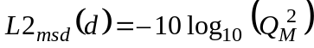

where:

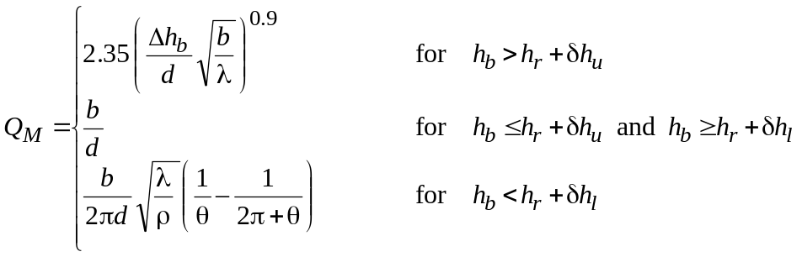

and

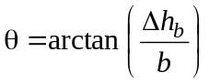

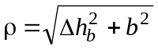

and 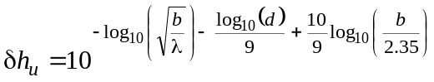

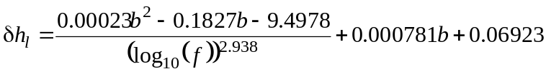

NoLoS over roof-tops for suburban area
The recommendation presents values for which the models are valid. However, for the purposes of comparison of proposals, such values can be relaxed a bit. Model is defined for the situation of h_{b} > h_{r} described in 2.1.1. The model is valid for
h_{r}: any height m
Δh_{b}: 1 to 100 m
Δh_{m}: 4 to 10 (less than h_{r}) m
h_{b}: h_{r} + Δh_{b} m
h_{m}: h_{r} − Δh_{m} m
f: 0.8 to 20 GHz
w: 10 to 25 m
d: 10 to 1 000 m
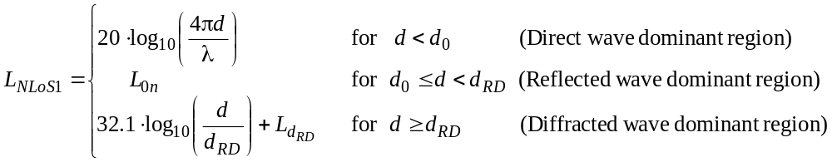 Equation 3
where:

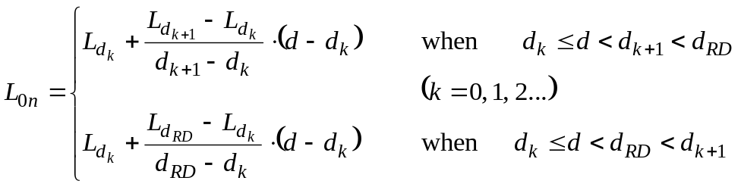

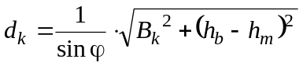

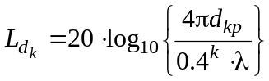

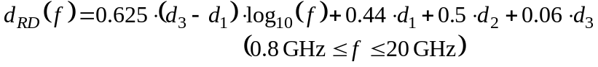

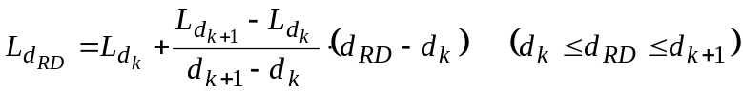

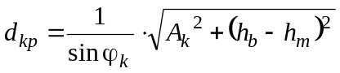

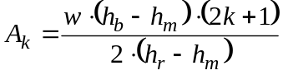
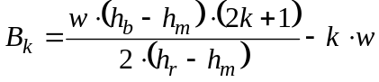

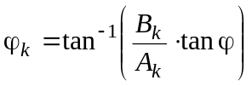

NoLoS in street canyons for sub-1 GHz band
For this NLoS situation both antennas are below roof-top level (see Figure 3 for reference).

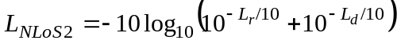 Equation 4

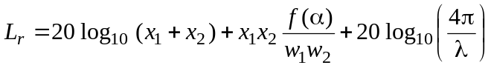
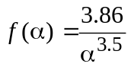 , 0.6 < α < π.

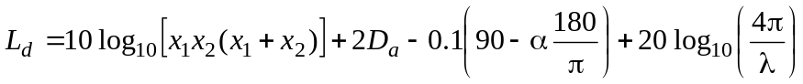

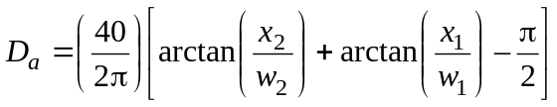

NoLoS in street canyons for 2.4 GHz and 5 GHz bands
This NLoS propagation model is described in 2.1.4 with the corner angle α = π/2. Such model assumes h_{b} < h_{r} and w₂ is up to 10 m (or sidewalk). Using x₁, x₂, and w_{1,} as shown in Figure 3, the overall path loss (L_{NLoS2}) beyond the corner region (x₂ > w₁/2 + 1) is given by
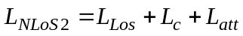 Equation 5

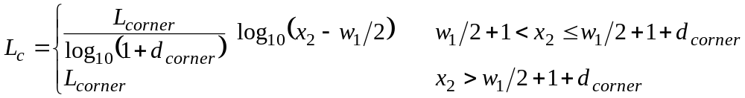

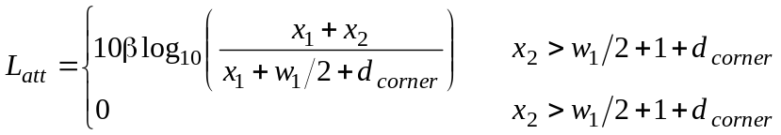
where L_{LoS} is the path loss in the LoS street for x₁ (> 20 m) is given in Equation 5. L_{corner} is given as 20 dB in an urban environment and 30 dB in a residential environment. d_{corner} is 30 m and β is 6 in both environments.

Outdoor Path Loss for UWB band
The outdoor path loss model for UWB band is based in the final report for UWB channel models document of former IEEE802.15.4a TG, as the propagation situations are the same for IEEE802.15.8 TG.
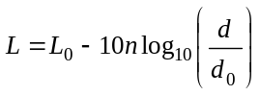 Equation 6
where d₀=1m is the reference distance, L₀ is path loss at the reference distance and n is path loss exponent.
L₀= -45.6 (LOS) , -73.0 (NLOS).
n= 1.76 (LOS) , 2.5 (NLOS).
d is valid up to 17m.

Indoor Path Loss

Attenuation Factor Model for 900 MHz band
An indoor propagation model that includes the effect of the building type and variations caused by obstacles is describe by Sei92b. This model is flexible and more accurate than the conventional log distance path loss model. The path loss is given by
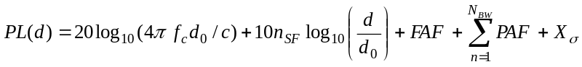 Equation 7
where d₀ is a reference distance, c is the speed of light, n_{SF} is the exponent of the same floor measurement. FAF is the floor attenuation factor for a specified number of building floors, PAF represents the partition attenuation factor for a specific obstruction encountered by a ray drawn between transmitter and receiver. X_{σ} represents a normal random variable in dB having a standard deviation of σ dB.
Alternatively, FAF may be replaced by n_{MF}, an exponent that considers the effects of multiple floor separation.
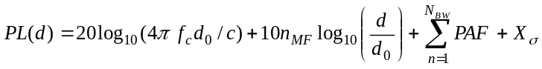 Equation 8

Example: An estimate of the path loss from a distance of 30m, through 3 floors of office building 1. Assume that 2 concrete block walls are between transmitter and receiver on the intermediate floors.
The mean path loss exponent for the same floor measurements in a building is n=3.27 (see Table 3). The mean path loss exponent for the three-floor measurements in a building is n=5.22 (see Table 3). The average floor attenuation factor for 3 floors is FAF=24.4 dB (see Table 2). The average attenuation for concrete block wall is PAF=13 dB (see Table 4) and N_{BW}=2. The reference distance is d₀=1m and f_{c}=900 MHz.
The mean path loss (without shadowing) using Equation 7 is given by
PL(30m)=31.5266+10*3.27log₁₀(30)+24.4+2*13=130.2 dB
The mean path loss (without shadowing) using Equation 8 is given by
PL(30m)=31.5266+10*5.22log₁₀(30)+2*13=108.6 dB

Table 2 Average floor attenuation factor in two office buildings
Building | FAF (dB) | σ (dB)
Office building 1
Through 1 floor | 12.9 | 7.0
Through 2 floor | 18.7 | 2.8
Through 3 floor | 24.4 | 1.7
Through 4 floor | 27.0 | 1.5
Office building 2
Through 1 floor | 16.2 | 2.9
Through 2 floor | 27.5 | 5.4
Through 3 floor | 31.6 | 7.2

Table 3 Path loss exponent for various types of buildings
Building | n | σ (dB)
All buildings
All locations | 3.14 | 16.3
Same floor | 2.76 | 12.9
Through 1 floor | 4.19 | 5.1
Through 2 floor | 5.04 | 6.5
Through 3 floor | 5.22 | 6.7
Grocery store | 1.81 | 5.2
Retail store | 2.18 | 8.7
Office building 1
Entire building | 3.54 | 12.8
Same floor | 3.27 | 11.2
West wing 5th floor | 2.68 | 8.1
Central Wing 5th floor | 4.01 | 4.3
West wing 4th floor | 3.18 | 4.4
Office building 2
Entire building | 4.33 | 13.3
Same floor | 3.25 | 5.2

Table 4 Average signal loss measurements for radio paths obstructed by common building materials
Material type | Loss (dB) | Frequency (MHz)
All metal | 26 | 815
Aluminum siding | 20.4 | 815
Foil insulation | 3.9 | 815
Concrete block wall | 13 | 1300
Metallic inventory | 4 - 7 | 1300
Loss from 1 floor | 20 - 30 | 1300
Ceiling duct | 1 - 8 | 1300

Indoor Path Loss for 2.4 GHz and 5 GHz bands
The site-specific model of Recommendation ITU-R P.1238-7 propagation and prediction methods for the planning of indoor radio communication systems and radio local area networks in the frequency range 900 MHz to 100 GHz is employed. Such propagation model would have the option of explicitly accounting for the loss due to each wall instead of including it in the distance model.

Ltotal = 20 log10 f + n log10 d + Lf (n) – 28 Equation 9
where:
n : distance power loss coefficient;
f : frequency (MHz);
d : separation distance (m) between the base station and portable terminal (where d > 1 m);
L_{f} : floor penetration loss factor (dB);
n : number of floors between base station and portable terminal (n ≥ 1).
Typical parameters are given in Table 5 and Table 6.

Table 5 Power loss coefficient, n.
Frequency | Residential | Office | Commercial
1.8-2 GHz | 28 | 30 | 22
2.4 GHz | 28 | 30
3.5 GHz |  | 27
4 GHz | – | 28 | 22
5.2 GHz | 30 (apartment)  28 (house) ⁽²⁾ | 31 | –
5.8 GHz |  | 24
²Apartment: Single or double storey dwellings for several households. In general most walls separating rooms are concrete walls.
House: Single or double storey dwellings for a household. In general most walls separating rooms are wooden walls.

Table 6 Floor penetration factor, L_{f}, with n being the number of floors penetrated.
Frequency | Residential | Office | Commercial
1.8-2 GHz | 4 n | 15 + 4 (n – 1) | 6 + 3 (n – 1)
2.4 GHz | 10⁽¹⁾ (apartment)  5 (house) | 14
3.5 GHz |  | 18 (1 floor)  26 (2 floors)
5.2 GHz | 13⁽¹⁾ (apartment)  7⁽²⁾ (house) | 16 (1 floor) | –
5.8 GHz |  | 22 (1 floor)  28 (2 floors)
⁽¹⁾ Per concrete wall.
⁽²⁾ Wooden mortar.

Small-Scale Fading
TBD

Bibliography
[1] Recommendation ITU-R P.1411-6 Propagation data and prediction methods for the planning of short-range outdoor radio communication systems and radio local area networks in the frequency range 300 MHz to 100 GHz.
[2] Seidel S., Rappaport T., “914 MHz Path Loss Prediction Models for Indoor Wireless Communications in Multifloor Buildings”, IEEE Transactions on Antennas and Propagation, Vol 40, No 2, February 1992, pp207-217.
[3] Recommendation ITU-R P.1238-7 Propagation data and prediction methods for the planning of indoor radio communication systems and radio local area networks in the frequency range 900 MHz to 100 GHz.
[4] IEEE802.15-04-0662-04-004a-channel-model-final-report-r1

